Islamabad institute
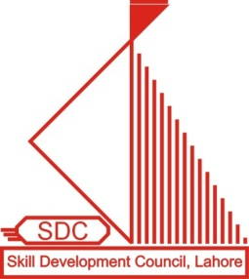
Of ultrasound training & education
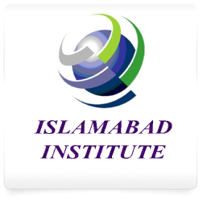
National Training Board (NTB)
Labour & Manpower Division
Government of PAKISTAN

ADMISSION FORM
PERSONAL INFORMATION
Name of Candidate |  |  |  |  |  |  |  |  |  |  |  |  |  |  |  |  |  |  | Photo
Father’s Name
Date of Birth |  | Day |  |  |  | Month |  |  |  |  |  |  | Year
Gender |  | Male |  |  |  |  |  |  |  | Female
Marital Status
CNIC
Address
City |  |  |  |  |  |  |  |  | Postal Code
Phone |  |  |  |  |  |  |  |  | Mobile
Email
EDUCATION
Year of Passing | Degree |  |  |  |  |  |  | Subject |  |  |  |  |  |  |  | Board/University
COURSE DETAIL
Course Title
Duration |  | 3 Months |  |  |  |  |  |  | 6 Months |  |  |  |  |  |  |  | 1 Year
Session
Institute Name
I HEREBY DECLARE THAT THE ABOVE INFORMATION IS BEST OF MY KNOWLEDGE

PRINCIPAL SIGNATURE
WITH OFFICIAL STAMP STUDENT SIGNATURE

FOR OFFICE USE ONLY
Reg. No. |  | Roll No.
Date of Registration |  | Completion Date

Islamabad Campus: 2nd Floor, Atta Muhammad Plaza, Near Ali Trust College, Opposite to Rawal Hospital
Contact: 051-5390421 Lehtraar Road, Khana, ISLAMABAD Email:

Islamabad institute
Of ultrasound training & education
NATIONAL TRAINING BOARD (NTB)
Labour & Manpower Division
Government of Pakistan

UNDERTAKING

I, ___________________________ S/O/D/O ______________________________ solemnly declare that I am a student of _________________ and got admission in the course of __________________ and will abide the rules and regulations as given below:

- That I will abide Code of Ethics of the College/Institute/SDC.
- That I understand that Skill Development Council, Punjab, Lahore is the training assessment and certifications issuing authority and all the training activities are the responsibility of college/institute. Therefore, I will not in any case approach SDC, Punjab, Lahore or National Training Board, Ministry of Labor, Manpower and Overseas Pakistanis officials directly or indirectly.
- That the Certificate/Diploma issued by the SDC, Punjab, Lahore does not have any guarantee of my job anywhere in Pakistan/Abroad.
- That I will not put any responsibility on SDC, Punjab, Lahore for the attestation of certificate/diploma from any agency in Pakistan/abroad.
- That I will not put any responsibility on the Institute/College as well as on Skill Development Council, Punjab, Lahore for any litigation.
- That I will not challenge Certificate/Diploma issued by the SDC, Punjab, Lahore in any court of law in Pakistan.
- During my study in the Institute/College, I will not involve myself in any type of political activities. I will not put any political and beaucratic pressure on the institute/college as well as on SDC, Punjab, Lahore.
- That I understand that SDC’s diploma/certificate does not have any equaliancy with any other board or agency in Pakistan.

In case of violation of any of above, The College/Institute is authorized to cancel my certificate/diploma issued by SDC, Punjab, Lahore.

I, _______________________ S/O/D/O _________________________ has signed this affidavit in confident. I have been told about all the consequences and losses for which I will myself responsible instead of putting the bar on the institute/college as well as Skill Development Council, Punjab, Lahore.

Signature of Student Principal Signature
With Thumb Impression with official stamp

